Introduction and History

The Don Deller Offshore Race was first held in 2009 to honour Dr Don Deller, one of the founding members of the BPYC, and is now an annual event.

The 2023 Don Deller Race Weekend, which will now be held on the weekend of 6 and 7 May (having been postponed from its original February date), will consist of:

- The Don Deller OFFSHORE Race, a single-division, PHS Offshore race from Port Jackson to Broken Bay consisting of boats of various types.
NOTE:
Those not wishing to enter the OFFSHORE Race are invited to cruise in company to Broken Bay.
- Post-race gathering: competitors, crew, members and supporters are invited to join the BPYC pre-dinner drinks at Royal Motor Yacht Club, followed by dinner in the RMYC Brasserie at their own cost. The winner of the Don Deller Trophy will be announced during the dinner.

Prizes will be awarded to 1st, 2nd and 3rd place, and an ‘encouragement award’ for the last placed yacht .

- The following morning, Sunday, boats are invited to cruise in company from Broken Bay to Port Jackson (this journey will depend on weather suitability and as always, it is at the owner’s discretion).

Finishing times will be corrected using TCFs determined by the SailSys handicapping system.

Each boat competing in the OFFSHORE Race must hold a current, audited Category 4 Safety Certificate and suitable insurance cover of not less than $10 million.

Entries close on Friday 28th April at 1700 hrs. Entries can be made by email to bluespointyc@gmail.com using the Entry Form attached to the Notice of Race.

(All entries and fees submitted for the postponed February race remain valid, provided that the same yacht is used and that it continues to hold Cat 4 and valid insurance).

Further information is available in the full Notice of Race (on the following pages). Please contact the Commodore of BPYC, Bill Steenson, either by email or by phone on 0478 617191 for more information or if you have any queries.

INVITATION
The Blues Point Yacht Club (BPYC), as the Organising Authority, invites boat owners from its own fleet and from other clubs affiliated with Australian Sailing, to enter the 2023 DON DELLER OFFSHORE RACE from Port Jackson to Broken Bay, and berth overnight at Royal Motor Yacht Club Broken Bay

The 2023 DON DELLER OFFSHORE RACE
Category 4 Safety-Rated Event:
- The race, commencing at 1030 hours on Saturday 6th May 2023, from a start line, in the vicinity of Obelisk Bay, which is the transit between the North Cardinal mark at ‘Sow and Pigs’ and the Western Channel PORT hand channel marker, passing the PORT hand marker to Starboard. The finishing line in the vicinity of Palm Beach Ferry Wharf, is the transit between Red Lateral beacon 002 (a red post with a can topmark) and red lateral mark 003 (immediately east of 002), passing 002 to Port.

Detailed communication, starting and finishing procedures will be included in the Sailing Instructions.
- At their own cost, entrants may berth overnight, enjoy pre-dinner drinks with other competitors at RMYC, before dining with BPYC at RMYC Broken Bay Brasserie, 6th May 2023.
(Please feel free to invite family and friends who are not sailing. Please note dress rules for some parts of RMYC (https://royalmotor.com.au/the-club/dress-rules).
The race entry form must be completed and must be lodged with BPYC no later than 1700 hrs, on Friday 28th April 2023.

Cruise in company from Broken Bay to Port Jackson
On Sunday morning, boats are invited to cruise in company from Broken Bay to Port Jackson (this journey will depend on weather suitability and as always, it is at the owner’s discretion).

ELIGIBILITY & ENTRY
Entry in the 2023 DON DELLER OFFSHORE RACE is open to:
- any boat owner who is a member of BPYC, regardless of whether any race fees have been paid for the current season;
- owners of boats that are registered with another club affiliated with Australian Sailing;
and
- boats which meet the Conditions of Entry:
- current Cat 4 Safety and Insurance Certificates (see below)- entered using the designated Entry Form below, and pay the Entry Fee.
Each boat must have a minimum of two persons on board (each with a valid AS number)

Entries close on Friday 28th April 2023 at 1700 hrs.

ENTRY FEE
The Entry Fee to the 2023 DON DELLER OFFSHORE RACE is $40.00 per vessel.
Race Entry Fees must be paid to BPYC at time of lodgement of Entry by EFT to the BPYC Westpac Bank account. (Account details are on the Entry Form below).

BERTHING FEE
RMYC charge $55 (and $75 if greater than 40ft) for overnight berthing at their Marina and, if required, this must be paid to BPYC at the time of lodgement of Entry.

Once paid, refund of berthing fees for non-use is at the sole discretion of RMYC Broken Bay and may not be available.

Crews of boats berthed at RMYC are welcome to use the facilities (showers, etc).

CONDITIONS OF ENTRY TO RACE

Risk Warning
The Organising Authority advises owners, skippers and anyone who participates in boating events that participation in the sport of boating, whether racing or otherwise, can be dangerous and can result in personal injury, death and property damage or loss. All participants acknowledge such risks and, by participating, they voluntarily accept them.

Disclaimer of Liability
- All persons taking part in this event do so at their own risk and responsibility. Attention is drawn to the Racing Rules of Sailing (RRS) Rule 3 (DECISION TO RACE) which states;
"The responsibility for a boat's decision to participate in a race or to continue racing is hers alone".
- The Organising Authority is not responsible for any harm or injury suffered by any person or damage to any vessel or personal equipment in any boating or associated event of whatever nature conducted by the Organising Authority.

Competitors’ Declarations
By entering and participating in this event, owners and skippers warrant to the Organising Authority that:
- their nominated vessel will comply at all times with RRS of World Sailing and the Prescriptions of Australian Sailing 2021-2024 and the Australian Sailing Special Regulations Part 1 (effective 1 July 2021) for Racing Boats and Recommended for Cruising Boats (Special Regulations) except where amended by the Sailing Instructions;
- their nominated vessel is covered by current Third-Party Property Liability insurance and Third Party Personal Liability insurance of not less than $10,000,000 (ten million dollars) for each incident and that such cover will be maintained during the period of this event;
- they have received the Risk Warning and Disclaimer of Liability above and release the Organising Authority from any claim or liability whatsoever for any harm, personal injury or damage suffered by any person, including any person claiming through the owner or skipper, in any event conducted by the Organising Authority.
- they will draw the attention of any person who competes on the boat to the Risk Warning and Disclaimer of Liability above.

SAFETY

Owners’ and Skippers’ Responsibilities
Owners and skippers have a responsibility to ensure that their vessel is seaworthy and continues to meet the requirements of its safety certificate.
It is "The responsibility for a boat's decision to participate in a race or to continue racing is hers alone" (RRS Rule 3).

Weather Dependency
This event will be postponed if Saturday and/or Sunday forecast winds offshore are > 25 knots or seas > 2.5 metres or if BOM has issued a Strong Wind Warning for Coastal Waters in the vicinity of the race.
A postponement decision will be communicated by SMS to each entrant as early as possible before the race but not later than 0800 hours on race day. It will also be broadcast on VHF Ch77 or alternate Ch 73, if the race is postponed after entrants have assembled at the starting line.

Safety Certificates
All participating boats are required to hold a current, audited Safety Certificate (Category 4) for DON DELLER OFFSHORE Race as per AS Special Regulations Part 1 (effective 1 July 2021) Section 2.
A copy of the relevant Safety Certificate must be received by the Organising Authority not later than 1700 hrs, Friday 28th April 2023. This is also required by RMYC if berthing at the club overnight.

It may be emailed to bluespointyc@gmail.com.

INSURANCE
All owners of vessels competing in the DON DELLER are required to hold Third-Party insurance cover of not less than $10 million for each separate incident and current on the date of the event. By entering their boat in this event, an owner warrants that their vessel’s insurance cover fulfils this requirement whilst under racing conditions. This is also required by RMYC for boats utilising an RMYC berth.

A copy of the Insurance Certificate of Currency must be received by the Organising Authority not later than 1700 hrs, Friday 28th April 2023.
It may be emailed to bluespointyc@gmail.com.

RULES
The race will be governed by the current Racing Rules of Sailing 2021-2024 (RRS) of World Sailing, the prescriptions and Special Regulations of Australian Sailing, and the Marine Safety Act 1998 Division 2: Duties of masters and owners in case of marine accidents, as amended by the Sailing Instructions.

HANDICAPS - PHS
The Organising Authority will determine the handicaps using SailSys System which will be a correction factor applied to a boat’s elapsed time. BPYC will establish and communicate handicaps for each boat prior to the race.

SAILING INSTRUCTIONS
The Sailing Instructions for the 2023 DON DELLER OFFSHORE RACE will be emailed to registered competitors no later than the week leading up to the event.

PRIZES
Prizes will be awarded to 1st, 2nd and 3rd place during the post-race dinner at RMYC.
The winner will also be announced, and awarded the DON DELLER Perpetual Trophy, at the BPYC Annual General Meeting in July 2023.

FURTHER INFORMATION:
Further Information may be available via the Club website at www.bpyc.com.au and will also be emailed to registered competitors.
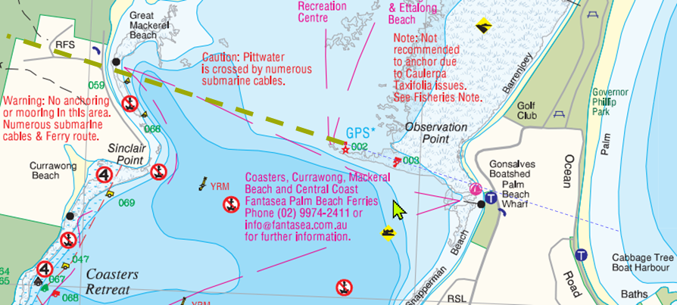
indicates finish (transit) line

ENTRY FORM – 2023 DON DELLER OFFSHORE RACE
(Please complete and return this form to BPYC, emailed to bluespointyc@gmail.com)

Closing date for entries is Friday 28th April 2023 at 17:00 hrs

Please enter the Yacht (name) ……………………….……

Yacht Type: ………………………………………. in the following events:

□ DON DELLER OFFSHORE RACE Saturday 6th May 2023

I agree to the Conditions of Entry and Other Instructions above.

………………………………………..……….. ………………………
(Name of Owner/Owner’s Representative) (Mobile Number)

……………………………………………………………………………….……….
(Club Name)

………………………………………………... ……………………….
(Signature) (Date)

□ I require a berth at RMYC Broken Bay for the night of 6th May 2023.

The following information is required by RMYC Broken Bay:
Vessel Owner(s): ……………………………………………
Contact Number of Skipper/Owner: ……………………………………………
Insurance Provider: ……………………………………………
Policy Number………………………………………
Policy Expiry Date: ………………………………………
L.O.A. (ft/m): …….…. Beam (ft/m): ………… Draft (ft/m): ……………
□ I will be attending the BPYC Dinner in the Brasserie at RMYC Newport
(all meals and drinks at own cost).
Please reserve ……… places for myself, my crew, friends and family
(this helps us to book sufficient seats for all)

I have transferred $............ to the following BPYC account, being for:
᫅ $40 for DON DELLER OFFSHORE Race entry
□ $55 for RMYC Berth

Direct debit payment to: BSB 032003 ACCOUNT: 269407
Payment Ref: DON DELLER [Yacht Name]

