BPYC invites boat owners from its own fleet and from other clubs affiliated with Australian Sailing to enter the 2023 DON DELLER OFFSHORE RACE from Port Jackson to Broken Bay, then berth overnight at Royal Motor Yacht Club Broken Bay.

Post-race, competitors, crew and friends are invited to join the BPYC pre-dinner drinks, followed by dinner in the RMYC Brasserie at their own cost. The winner of the Don Deller Trophy will be announced during the dinner.

Finishing times will be corrected using TCFs determined by the SailSys handicapping system.

Prizes will be awarded to 1st, 2nd and 3rd place, as well as an ‘encouragement award’ for last place.

Each boat competing in the OFFSHORE Race must hold a current, audited Category 4 Safety Certificate and suitable insurance cover of not less than $10 million. Refer to clause 5 below.

Boats not entering the race may also cruise in company to Pittwater and berth overnight by prior arrangement. All members and supporters are encouraged to attend the post-race events at RMYC.

RULES

The Race shall be governed by the current version of the rules as defined in the Racing Rules of Sailing (RRS) of World Sailing and the Prescriptions of Australian Sailing and the Australian Sailing Special Regulations Part 1 for Racing Boats (effective 1 July 2021) and Recommended for Cruising Boats (Special Regulations) except where amended by these SIs.

RRS 90.2(c) is amended as follows:
The Sailing Instructions may be changed provided the change is in writing and advised to potential competitors at least eight hours before the start time of the race/event or, on the water, communicated orally to each boat before her warning signal. Written changes may be provided by email or SMS.

COMMITTEES

The Sailing Committee shall be the Race Committee (RC) for the purposes of and within the powers and discretions contained in RRS 90.1.

The Sailing Committee and RC comprises the Commodore, Vice-Commodore, Starter and Principal Race Officer. The Principal Race Officer (PRO) who may also be the Starter is nominated for each race and is chosen from among those Committee members participating in the race. For this race, the PRO is Bill Steenson (Ph: 0478 617191) will be communicating via VHF Channel (Ch) 77, the alternate Ch is Ch 73.

The Protest Committee comprises the Commodore or Vice-Commodore, one BPYC Committee member other than the Commodore or Vice-Commodore, and an external expert to be appointed by the BPYC Committee. The BPYC Committee members are defined in the Constitution. If one or more of these persons is a party to the protest, they will not participate in the Protest Committee.

RESPONSIBILITIES

All persons taking part in BPYC races and events do so at their own risk and responsibility.

The BPYC and its officers, volunteers and members accept no liability for any injury, loss or damage that may be suffered by any competitor and any liability for harm to persons. BPYC gives no express or implied warranty that its races and events and all services relating thereto will be conducted with reasonable care and skill.
Attention is drawn to RRS Rule 3 (DECISION TO RACE) that states
“The responsibility for a boat’s decision to participate in a race or to continue racing is hers alone.”

Attention is drawn to Australian Sailing Special Regulation 1.02.1 that states, in part, “The safety of a boat and her crew is the sole and inescapable responsibility of the person in charge who shall do their best to ensure that the boat is fully found, thoroughly seaworthy and manned by an experienced crew who have undergone appropriate training and are physically fit to face bad weather. They must be satisfied as to the soundness of hull, spars, rigging, sails and all gear. They shall ensure that all safety equipment is properly maintained and stowed and that the crew know where it is kept and how it is to be used. … They shall also nominate a person to take over the responsibilities of the person in charge in the event of his incapacitation.”

Owners and masters of vessels have responsibilities under NSW legislation, particularly the Marine Safety Act 1998 (MSA 1998) and the Marine Safety Regulation 2016. Owners and masters participating in BPYC events should note their responsibilities under the legislation, especially MSA 1998 Division 2: Duties of masters and owners in case of marine accidents (see Appendix A of these SIs).

Attention is drawn to RRS Fundamental Rule 1: “A boat, competitor or support person shall give all possible help to any person or vessel in danger.”

Each boat competing in the race must hold suitable insurance coverage, with a sum insured of not less than ten million Australian dollars.

All boats must give priority of passage to a vessel displaying an orange diamond on Sydney Harbour.

All boats must maintain a minimum distance of 500m from the bow of any oil tanker or sea-going cruise ship and 200m from the bow of any other sea-going commercial vessel or ferry operating in accordance with and approved schedule, and no less than 30m from the sides/stern of any ship or ferry underway (see Marine Safety Regulation 2016).

Attention is drawn to RRS 46: Person-in-Charge to have an Australian Sailing Number (SIN) and all crew holding a SIN or Sail Pass. Attention is also drawn to RRS 75:
To enter an event, a boat shall comply with the requirements of the organising authority of the event. She shall be entered by:

a member of a club or other organisation affiliated to a World Sailing member national authority,

such a club or organisation, or

a member of a World Sailing member national authority.

The person in charge of a boat is responsible for ensuring that all crew comply with RRS 47: (TRASH DISPOSAL) “A competitor shall not intentionally put trash in the water. This rule applies at all times while afloat. The penalty for a breach of this rule may be less than disqualification.” In order that BPYC may be recognised as a good environmental citizen, owners and all crew are encouraged to recycle containers to the maximum extent possible.

Competitors are required to notify the Organising Authority of any contact incident occurring during racing regardless of whether it results in a Protest or a report to NSW Roads and Maritime Services.

Each boat shall be crewed by a minimum of two persons.

FURTHER SAFETY REQUIREMENTS AND ADVICE

Weather Dependency
This event will be postponed if, on the race morning or day prior, the forecast wave height is greater than 2.5 metres or if BOM has issued a Strong Wind Warning for Coastal Waters between Port Jackson and Pittwater, or for Sydney Enclosed Waters.

A postponement decision will be communicated by SMS to each entrant as early as possible before the race but not later than 0800 hours on race day. It will also be broadcast on VHF Ch77, or alternate Ch 73 if in use, if the race is postponed after entrants have assembled at the starting line.

Safety Briefing
Prior to departing Port Jackson (and prior to departing Pittwater for any new crews making the return voyage), skippers shall provide their crew with a safety briefing (location and use of safety gear, man overboard (MOB) procedures including if skipper is MOB, starting and stopping the motor, etc). A suitable safety briefing can be found at Safe-Skipper.com.

Log On/Log Off with Marine Rescue
Each vessel shall log-on and log-off with Marine Rescue (VHF Channel 16 or via the Marine Rescue app) prior to departing Port Jackson and on arrival at Pittwater, and vice-versa for the return journey.

Return Voyage
Any return voyage to Port Jackson after the race is not part of this event. Any information given above in regard to the return voyage is solely for the purpose of helping to provide safe passage.

SPECIAL REGULATIONS

A boat shall comply with Safety requirements of the Australian Sailing Special Regulations Part 1 for Racing Boats (effective 1 July 2021).

Each boat competing in the OFFSHORE Race must hold a current, audited Category 4 Safety Certificate and suitable insurance cover of not less than $10 million.

Designated representatives of BPYC may inspect a boat under Special Regulation 2.02.

STARTING PROCEDURE

The start line is (in the vicinity of Obelisk Bay) a transit between the North Cardinal mark at Sow and Pigs and the Western Channel port hand channel marker, passing the port hand marker to Starboard. See figure 1 below.

Figure 1

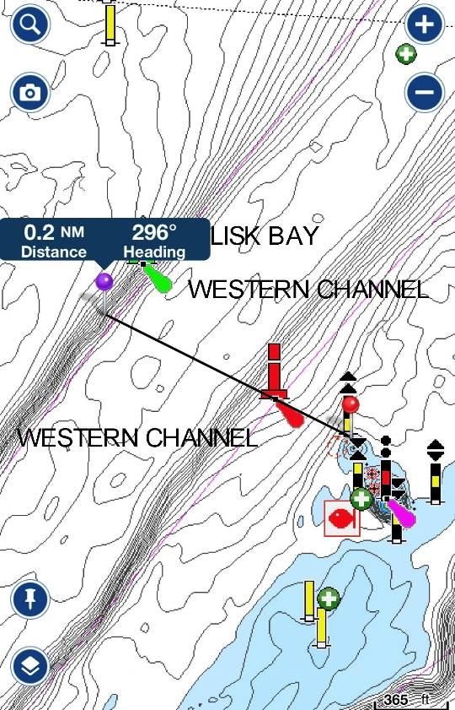

The PRO will on station in the vicinity of the start line (Bill Steenson 0478 617191).

The nominated time of the starting signal will be 1030hrs. The Starter may alter the start time at his discretion.

At any time before the starting signal the Starter may, for any reason, postpone the start by displaying the IC Flag AP with two sound signals (RRS 27.3). In addition, the Starter shall announce by VHF Ch77 or alternate Ch 73, that the race has been delayed.

At any time the Starter, after consultation with the Race Committee if available, may for any reason abandon the race by three sound signals (amends RRS 27.3). In addition, the Starter shall announce by VHF Ch77 or alternate a Ch 73, that the race has been abandoned.

RRS 26 is amended as follows:

Minutes before Starting Signal | Visual Signal | Sound Signal | Means
10 | Hoist IC Flag I | One | Warning Signal
5 | Drop IC Flag I;  Hoist IC Flag P | One | Preparatory Signal for Race Start
0 | Drop IC Flag P | One | Starting Signal

In the event a start boat is not available, the start will be made by either the Commodore or Vice Commodore on VHF Ch77 or alternate channel is Ch 73, as below.

Minutes before Starting Signal | Sound Signal | Means
 | By VHF Ch77 | 10 Sec countdown to the 10 min signal
10 | One | Warning Signal
5 | One | Preparatory Signal for Race Start
 | By VHF Ch77 | 10 Sec countdown to the start
0 | One | Starting Signal

Except in emergency (Mayday or Pan-Pan), no boat shall contact the starter between the Warning Signal and the Starting Signal. Except in emergency, the Starter has no obligation to respond to any such contact during that period.

  - OCS: Should a boat cross the start line ahead of their scheduled start time, they are deemed to be OCS and need to return to the start line OUTSIDE either end of the start line and restart. The Starter should alert the boat with 2 hoots of the horn and notify the boat by NAME over the VHF race channel announcing they have started prematurely. If the boat does NOT return and restart, the starter will mark the boat as OCS and the boat will receive a 5 minute penalty.

FINISHING PROCEDURE

The finishing line is in the vicinity of Palm Beach Ferry Wharf: a transit between Red Lateral beacon 002 (a red post with a can topmark) and red lateral mark 003 (immediately east of 002), passing 002 to Port. See figure 2 below.

Boats must record their own finish time as they cross the transit between Red Lateral beacon 002 and red lateral mark 003. SMS your finish time to the PRO on 0478 617191.

Figure 2

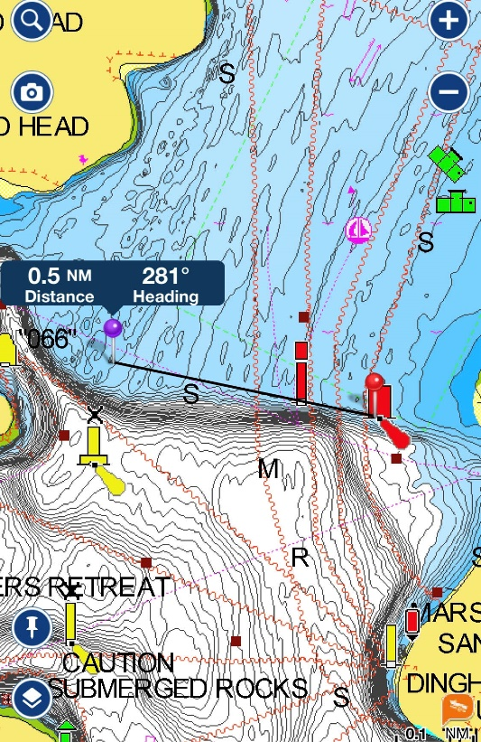

SHORTENED COURSES (amends RRS 32)

A course may be shortened at any time before the first boat crosses the finish line (the finish line may be that of the shortened course).

The Race Finish Committee boat shall announce the shortened course via broadcast on VHF Channel 77 or alternative Channel 73.

RACE TIME LIMIT AND SCORES (RRS 35)

The time limit for the race is 16:30hrs.

If one boat starts, sails the course and finishes within the time limit for that race, if any, all boats that finish shall be scored according to their corrected finishing places unless the race is abandoned. If no boat finishes within the race time limit, the race committee shall abandon the race.

HANDICAPS

Handicaps using SailSys System will be a correction factor applied to a boat’s elapsed time.

BPYC will establish and communicate handicaps for each boat prior to the race.

ONE BOAT CONSTITUTES A RACE

When only one boat starts and sails the course and finishes within the time limit, it shall be declared the winner and the race shall not be abandoned (RRS 32.1).

PENALTIES

Penalties shall be taken as soon as possible to the time of incident as per RRS 44.

PROTESTS AND REQUEST FOR REDRESS

All protest shall be made, and Protest meetings conducted, as per the RRS except as amended here.

Protests shall be in writing and submitted to the Commodore, or the Vice Commodore or in their unavailability another member of the Club Committee.

The time limit for a written protest to be lodged to BPYC is two hours after the Protestor’s race finishing time, but no later than 1800hrs on the day of the alleged incident.

The boat protested against should be immediately notified by the Committee member, verbally, or by text message or by email, that the protest has been lodged and the alleged infringement incident.

RRS Appendix T Arbitration will apply.

If the protest situation still exists at the conclusion of the arbitration, the protest will be heard by a Protest Committee.

At the conclusion of the above processes the race result shall then be declared.

PROHIBITED AREAS/OBSTRUCTIONS

For the purposes of RRS 19 the following are continuing obstructions and prohibited areas. Special mention is to note the continuing obstruction of Long Reef:

Caution - Particular Hazards
Particular hazards between Port Jackson and Barrenjoey Head include, but are not restricted to:
- South Reef (33°49.92’S 151°16.91’E) on departing harbour
- Long Reef (33°44.54’S 151°19.58’E) off Collaroy
- Little Reef (33°39.68’S 151°19.98’E) south of Newport Beach
- Bommies to North and Northwest of Barrenjoey Head.

Skippers should also be alert for buoys connected to traps. In 2018, a large headsail was seen floating just below the surface off Barrenjoey, so expect the unexpected!

COMMUNICATION

All boats, including Committee Boats, shall:

Monitor and use VHF Ch 77; use VHF Ch 73 if Ch 77 is busy.

Monitor VHF Ch 16 (dual watch with Ch 77 or alternative Ch 73, if in use).

As a minimum, monitor the above-mentioned channels between 30 mins before starting and 10 minutes after finishing or until notifying the PRO if withdrawing from the event.

Any boat withdrawing from the race shall advise the Race Start or Race Finish Committee Boat (notifying the relevant boat depending on the time of withdrawal) on VHF Ch 77, or its alternative VHF Ch 73 if in use. Alternatively call the PRO on 0478 617191

Attachments
1. BPYC Chartlet for Port Jackson 20200826

